**PROOF OF TESTING**

**MATLAB Problem 4**

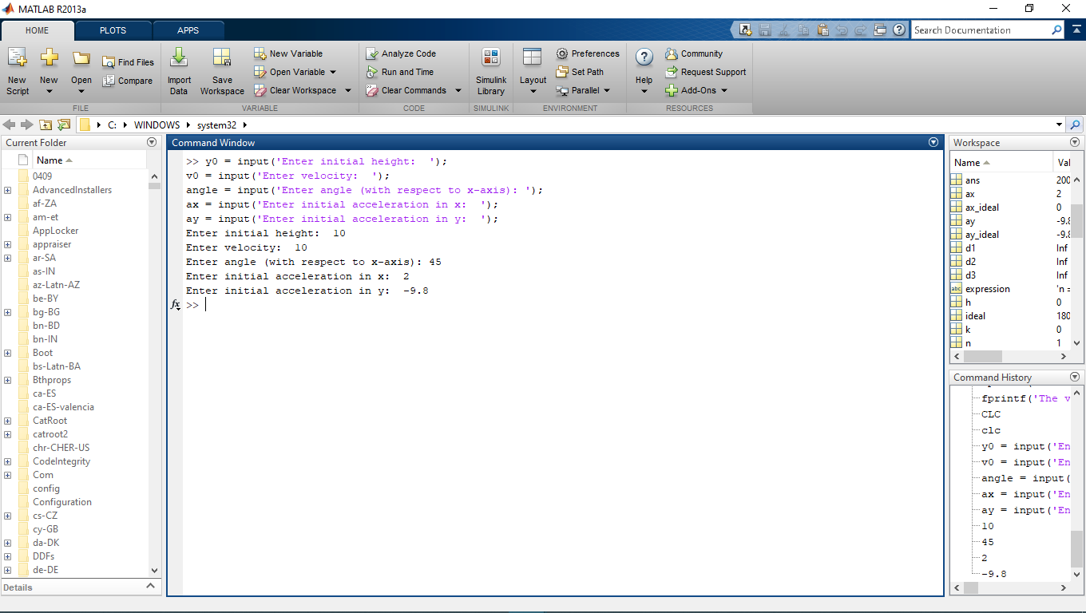**For vertical acceleration not equal to zero:**

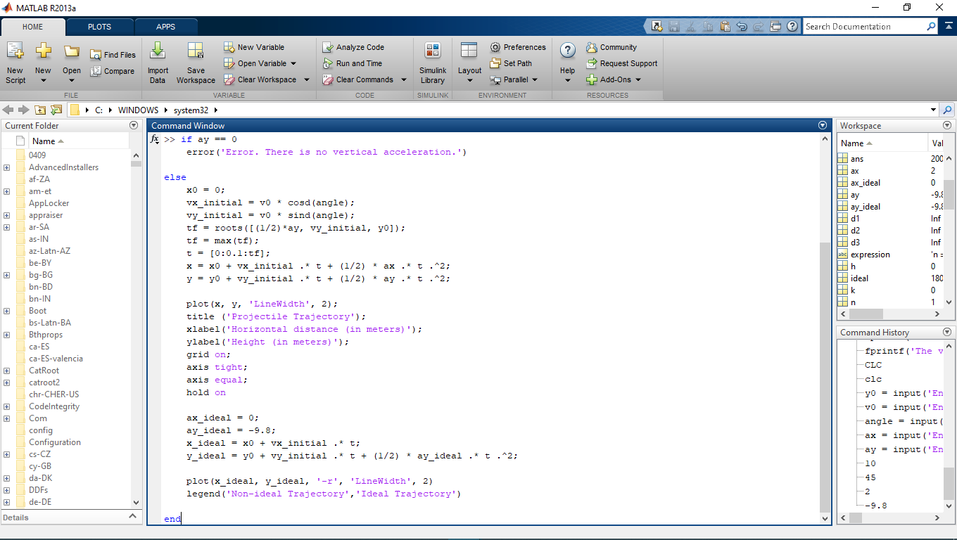

**For ideal trajectory**

**For non-ideal trajectory**

**Input initial height, velocity, angle, and acceleration for both x and y.**

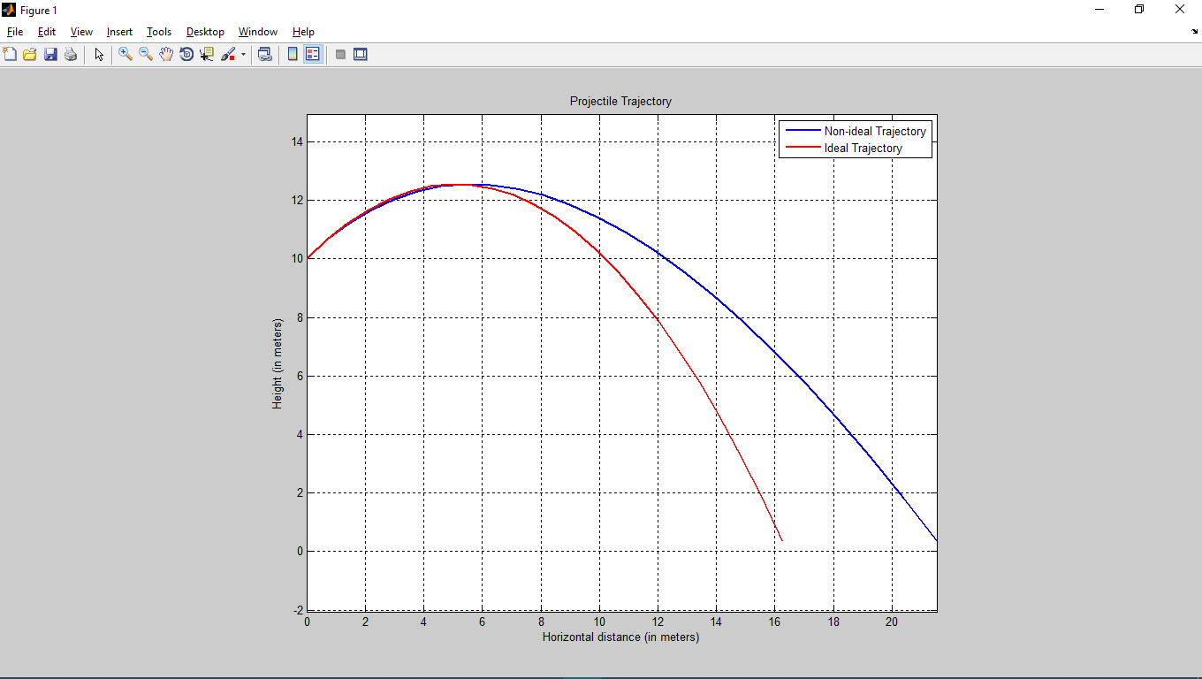

**Plot generated**

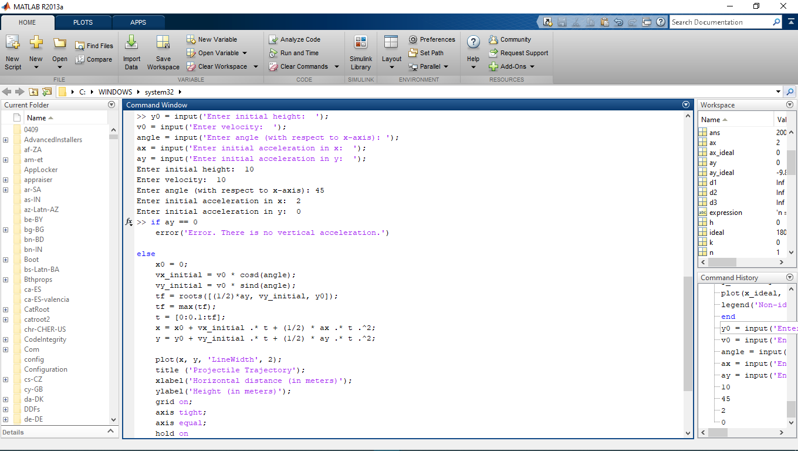**For vertical acceleration equal to zero:**

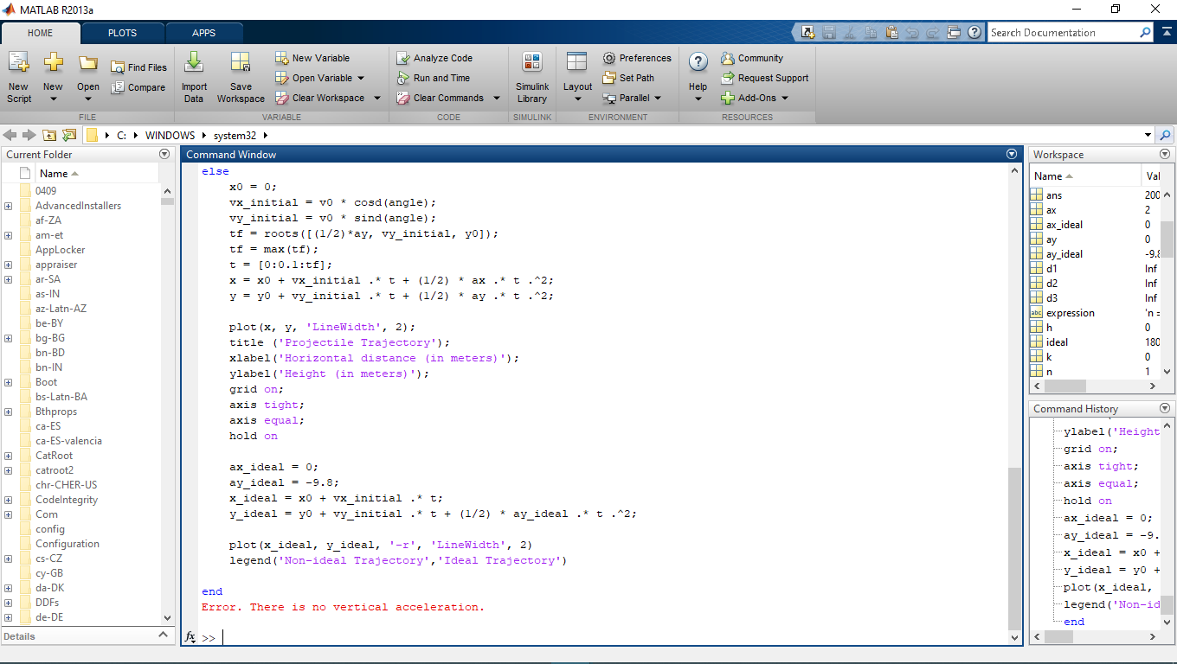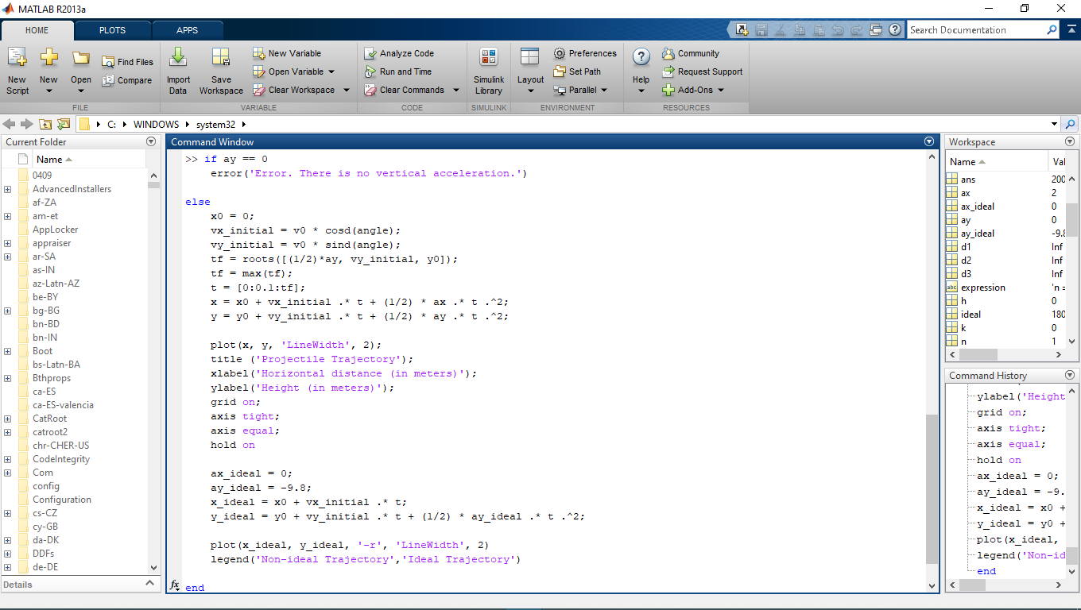**No plot generated.**

**Displays error message.**

**Input vertical acceleration as zero**